IMPORTANT NOTICE

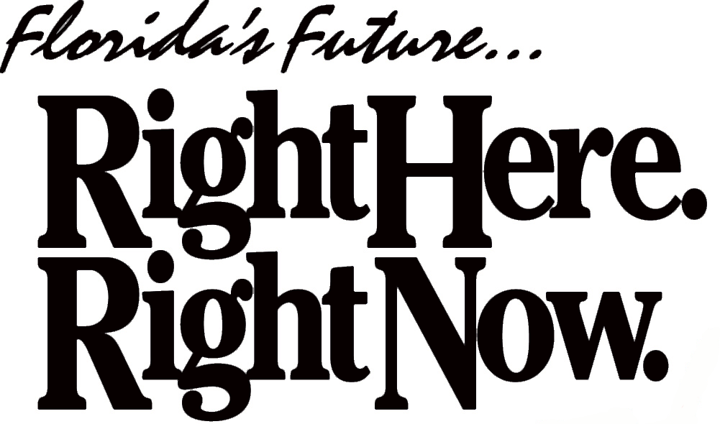

Jeb Bush

Governor

Virgil Rizzo, M.D.,J.D.
Condominium Ombudsman

Tallahassee
1940 North Monroe Street
Tallahassee, FL 32399-1031

Fort Lauderdale
P.O. Box 22520
Fort Lauderdale, FL 33335

VOICE
(850) 922-7671
(954) 202-3234

INTERNET
www.myflorida.com
Ombudsman@dbpr.state.fl.us

TO: Board of Directors

FROM: Virgil Rizzo, Condominium Ombudsman

SUBJECT: Reconstruction And Repair After A Casualty

DATE: November 1, 2005
A Condominium Association is a Florida corporation that must comply with the applicable requirements of Chapter 617 (the Florida Not For Profit Corporation Act), Chapter 718 (the Condominium Act) of the Florida Statutes and Chapter 61B-15 through 61B-25 of the Florida Administrative Code (FAC).
The following are the association’s obligations after a casualty.
The Master Insurance policy (hazard insurance) is to cover, up to its limits and less the deductible, all damage to the common elements, limited common elements and each unit due to a casualty. This should be stated in the Declaration of Condominium. The premises shall be repaired or reconstructed to substantially the same condition existing immediately prior to the casualty and substantially in accordance with the original plans and specifications of the condominium and any subsequent modifications thereto. The extent of this damage should be determined within 60 days or sooner after the casualty.
Florida Statute 718.111(11) only governs current insurance obligations.
If there are damages to the common elements, limited common elements, and units that exceed the policy limits of the Master Policy, the association must obtain the balance exactly as stated in the Declaration of Condominium under casualty loss. The balance may be obtained by use of the specific reserves, special assessment to unit owners, or by a loan or mortgage. Some declarations permit assessments against unit owners for damage to the units according to the cost of reconstruction or repair of their respective units.
The association is responsible to have the common elements, the limited common elements, and the individual units repaired or reconstructed without delay.
Please see that this is undertaken as soon as possible after the casualty so that the members may again enjoy life in their association. The sooner the association acts the less likelihood further damage will occur.
Feel free to contact me, if you have any questions regarding this matter.
Sincerely,

Virgil Rizzo, M.D.,J.D.
Condominium Ombudsman For The State Of Florida

